|  |
| --- |
| Jeremy Holloway |
|  |

|  |  |
| --- | --- |
| 9/23/2018 | Technical Report |

|  |
| --- |
| Prepared for Kevin Plis  Prepared by Jeremy Holloway  CPSC-2150-001  Fall 2018 |

Table of Contents

1. Requirement Analysis 2

2. Design 3

3. Testing Methods 4

4. Deployment 9

|  |
| --- |
|  |

# 1. Requirement Analysis

**User Story:**

* As a user, I can choose which column to place a token in order to win the game.

**Functional Requirements:**

* A user will be able to choose which column to place their token.
* A user will be able to choose to play again after winning, losing, or drawing.

**Non-Functional Requirements:**

* The program will automatically determine if a winning move is made after each turn or if a draw has occurred.
* The program will have an instant response time.
* The program is modular. If the client desires to remove certain functions, they may be commented out. These methods will work on any system with JDK8 installed.
* The program is written in Java. The system must have JDK8 installed. The program was designed for a Unix based environment.
* This program will use a makefile with the commands; make, make run, and make clean.
* All interfaces between the user and the app will be displayed via the terminal window.

# 2. Design

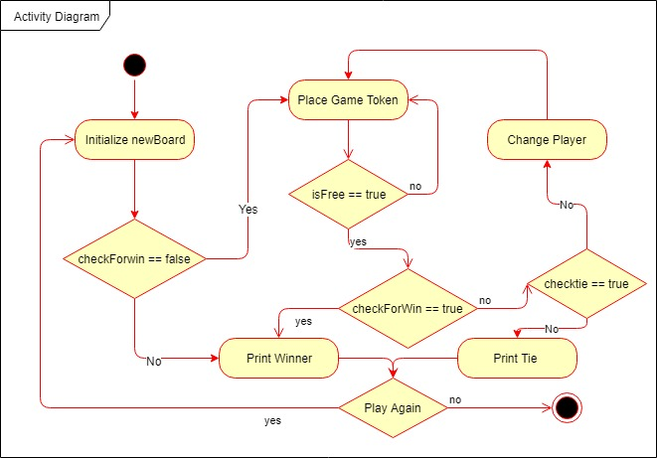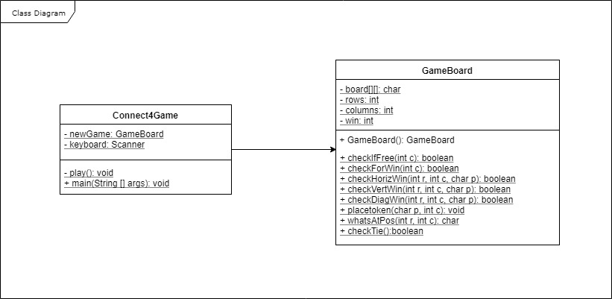

# 3. Testing Methods

**Sample input and output**

|0|1|2|3|4|5|6|

| | | | | | | |

| | | | | | | |

| | | | | | | |

| | | | | | | |

| | | | | | | |

| | | | | | | |

Player X, what column do you want to place your marker in?

3

|0|1|2|3|4|5|6|

| | | | | | | |

| | | | | | | |

| | | | | | | |

| | | | | | | |

| | | | | | | |

| | | |X| | | |

Player O, what column do you want to place your marker in?

3

|0|1|2|3|4|5|6|

| | | | | | | |

| | | | | | | |

| | | | | | | |

| | | | | | | |

| | | |O| | | |

| | | |X| | | |

Player X, what column do you want to place your marker in?

3

|0|1|2|3|4|5|6|

| | | | | | | |

| | | | | | | |

| | | | | | | |

| | | |X| | | |

| | | |O| | | |

| | | |X| | | |

Player O, what column do you want to place your marker in?

3

|0|1|2|3|4|5|6|

| | | | | | | |

| | | | | | | |

| | | |O| | | |

| | | |X| | | |

| | | |O| | | |

| | | |X| | | |

Player X, what column do you want to place your marker in?

3

|0|1|2|3|4|5|6|

| | | | | | | |

| | | |X| | | |

| | | |O| | | |

| | | |X| | | |

| | | |O| | | |

| | | |X| | | |

Player O, what column do you want to place your marker in?

3

|0|1|2|3|4|5|6|

| | | |O| | | |

| | | |X| | | |

| | | |O| | | |

| | | |X| | | |

| | | |O| | | |

| | | |X| | | |

Player X, what column do you want to place your marker in?

3

Column is full

Player X, what column do you want to place your marker in?

4

|0|1|2|3|4|5|6|

| | | |O| | | |

| | | |X| | | |

| | | |O| | | |

| | | |X| | | |

| | | |O| | | |

| | | |X|X| | |

Player O, what column do you want to place your marker in?

5

|0|1|2|3|4|5|6|

| | | |O| | | |

| | | |X| | | |

| | | |O| | | |

| | | |X| | | |

| | | |O| | | |

| | | |X|X|O| |

Player X, what column do you want to place your marker in?

2

|0|1|2|3|4|5|6|

| | | |O| | | |

| | | |X| | | |

| | | |O| | | |

| | | |X| | | |

| | | |O| | | |

| | |X|X|X|O| |

Player O, what column do you want to place your marker in?

-1

Column cannot be less than 0

Player O, what column do you want to place your marker in?

8

Column cannot be greater than 6

Player O, what column do you want to place your marker in?

0

|0|1|2|3|4|5|6|

| | | |O| | | |

| | | |X| | | |

| | | |O| | | |

| | | |X| | | |

| | | |O| | | |

|O| |X|X|X|O| |

Player X, what column do you want to place your marker in?

1

|0|1|2|3|4|5|6|

| | | |O| | | |

| | | |X| | | |

| | | |O| | | |

| | | |X| | | |

| | | |O| | | |

|O|X|X|X|X|O| |

Player X Won!

Would you like to play again? Y/N

m

Would you like to play again? Y/N

y

|0|1|2|3|4|5|6|

| | | | | | | |

| | | | | | | |

| | | | | | | |

| | | | | | | |

| | | | | | | |

| | | | | | | |

Player X, what column do you want to place your marker in?

1

|0|1|2|3|4|5|6|

| | | | | | | |

| | | | | | | |

| | | | | | | |

| | | | | | | |

| | | | | | | |

| |X| | | | | |

Player O, what column do you want to place your marker in?

2

|0|1|2|3|4|5|6|

| | | | | | | |

| | | | | | | |

| | | | | | | |

| | | | | | | |

| | | | | | | |

| |X|O| | | | |

Player X, what column do you want to place your marker in?

1

|0|1|2|3|4|5|6|

| | | | | | | |

| | | | | | | |

| | | | | | | |

| | | | | | | |

| |X| | | | | |

| |X|O| | | | |

Player O, what column do you want to place your marker in?

2

|0|1|2|3|4|5|6|

| | | | | | | |

| | | | | | | |

| | | | | | | |

| | | | | | | |

| |X|O| | | | |

| |X|O| | | | |

Player X, what column do you want to place your marker in?

1

|0|1|2|3|4|5|6|

| | | | | | | |

| | | | | | | |

| | | | | | | |

| |X| | | | | |

| |X|O| | | | |

| |X|O| | | | |

Player O, what column do you want to place your marker in?

2

|0|1|2|3|4|5|6|

| | | | | | | |

| | | | | | | |

| | | | | | | |

| |X|O| | | | |

| |X|O| | | | |

| |X|O| | | | |

Player X, what column do you want to place your marker in?

1

|0|1|2|3|4|5|6|

| | | | | | | |

| | | | | | | |

| |X| | | | | |

| |X|O| | | | |

| |X|O| | | | |

| |X|O| | | | |

Player X Won!

Would you like to play again? Y/N

n

Process finished with exit code 0

# 4. Deployment

This program will include a make file which can be used for three operations make, make run, make clean. The makefile must be in the same folder as cpsc2150 and not inside of it or any other subfolder.

**make:**

Expected output:

javac cpsc2150/connectX/Connect4Game.java

**make run:**

Expected output:

java cpsc2150.connectX.Connect4Game

**start of game**

**make clean:**

Expected output:

rm -f *.class